

`

**9**

**Homeroom Guidance**

**Quarter 1 – Module 2:**

**Conquering the Clouds of Challenges**

**Name:** Paul Gerald D. Pare

**Section:** 9 - Adenine

**Homeroom Guidance Self-learning Module – Grade 9** Quarter 1 Module 2: Conquering the Clouds of Challenges 2020 Edition

**The Intellectual Property Code of the Philippines** states that “No copyright shall subsist in any work of the Government of the Philippines. However, prior approval of the government agency or office wherein the work is created shall be necessary for exploitation of such work for profit. Such agency or office may, among other things, impose as a condition the payment of royalties.”

Borrowed materials (e.g., texts, illustrations, musical notations, photos, and other copyrightable, patentable contents) included in this learning resource are owned by their respective copyright and intellectual property right holders. Where applicable, DepEd has sought permission from these owners specifically for the development and printing of this learning resource. As such, using these materials in any form other than agreed framework requires another permission and/or licensing.

No part of this material, including its original and borrowed contents, may be reproduced in any form without written permission from the Department of Education.

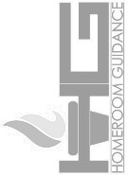**Recommended Entry for Citation Purposes:**

Department of Education. *Homeroom Guidance Grade 9 Self-learning Module 2: Conquering the Clouds of Challenges.* Manila: Department of Education Central Office, 2020.

Published by the Department of Education Secretary: Leonor Magtolis Briones Undersecretary: Diosdado M. San Antonio Assistant Secretary: Alma Ruby C. Torio

**Development Team**

**Writer:** Crissa P. Zamoranos

**Grade Level Coordinator:** Melanie O. Mandin

**Editors:** Mark Anthony Bercando, Jona Kristen Valdez, Melynda Andres

**Illustrators:** Jayson R. Gaduena, Jerichko Bauer L. Laroco, Marieto Cleben V. Lozada, Mark Dave M. Vendiola, Katrina S. Padilla, Grace Ann A. Caldito, and Cherry Amor

R. Laroza

**Layout Artists:** Jacqueline E. Libut and Cherry Amor R. Laroza

**Management Team:**

* Bureau of Curriculum Development: Jocelyn DR. Andaya, *Director IV*, Ma. Isabel Victorino, *CSDD Chief*, Mark Anthony Bercando, *Supervising EPS*, Jona Kristen Valdez, Melynda Andres, *Senior EPS*
* Bureau of Learning Resources

**Homeroom Guidance Grade 9 Quarter 1 – Module 2:**

**Conquering the Cloud of Challenges**

Gabay sa Magulang/Tagapag-alaga



Isinulat ang modyul na ito upang gabayan ang mag-aaral na maging mapanuri sa mga pagsubok na kaniyang naranasan at kung paano niya pinagtagumpayan ang mga ito nang may tatag, sigla at saya. Pag- aaralan din sa modyul na ito ang mga epekto ng iba’t ibang epektibong gawi sa pag-aaral o *study habits*. Dinisenyo ito para sa *distance learning* o alternatibong pamamaraan ng pagkatuto na hindi nangangailangan ng pisikal na presensya sa paaralan, bilang tugon sa direktiba na pagkansela ng *face-to-face class* dulot ng pandemyang Covid-19.

Maaaring may mga pagkakataon na hihingiin ng mag-aaal ang inyong patnubay sa pagsunod sa mga tagubilin, pagsagot sa mga tanong sa bawat bahagi ng mga gawain at maging sa pagkakaroon ng mga kakailanganing materyales base sa nakatakdang gawain. Hinihiling ng Kagawaran ang inyong suporta upang matagumpay niyang maisakatuparan ang mga gawain. Makatutulong ang araling ito upang hubugin ang kaniyang kabutihan na tanggapin ang pagkakaiba-iba ng bawat tao sa katangian, kakayahan, damdamin at pananaw. Tiyakin na sasagutin niya ang bawat bahagi ng modyul nang tapat.

Kinakailangan din ang long folder na magsisilbing *portfolio* ng mag- aaral sa Homeroom Guidance. Dito isisilid lahat ng gawaing natapos sa bawat bahagi ng modyul. Tiyaking ito maipapasa ito sa petsa at oras na itinakda ng kanyang gurong-tagapayo.

**Introductory Message**

For the learner:

As part of examining your life while trying to adjust to the new normal, it is important to evaluate your strength and weaknesses. Doing so will help you with the adjustments that you will need for the next stage of your life. This can help you understand the things that happen around you and to effectively deal with different challenges.

Work on the tasks seriously; seek help if you believe you need to. Remember, in life there are things that you cannot control. There will be negative events that will challenge your positive dispositions. However, do not be disheartened: you have the means on how to overcome it – you have that in you! Embark on this journey of overcoming your weaknesses and optimizing your strengths to attain your better version.

This self-learning module has six interactive tasks such as:

**Let’s Try This** – which will help you to get ready to learn;

**Let’s Explore This** – which will guide you towards what you need to learn;

**Keep in Mind** – which will give you the lessons that you need to learn and understand; **You Can Do It** – which will help you apply the lessons learned in daily activities; **What I Have learned** – which will test and evaluate your learning.

**Share Your Thoughts and Feelings** – which will help you express your thoughts, opinions and feelings.

Make sure to read, think, follow, and enjoy every task that you are asked to do.

Have fun! Stay safe and healthy!

|  |  |
| --- | --- |
| **MODULE 2** | **CONQUERING THE CLOUDS OF**  **CHALLENGES** |

# C:\Users\ZhanylleZafrina\AppData\Local\Microsoft\Windows\INetCache\Content.Word\Artboard 8@5x.pngLearning Objectives

At the end of the learning session, you are expected to:

1. identify the different challenges encountered in dealing with school activities and how these challenges were dealt positively;
2. compare the pros and cons in utilizing the various study habits; and
3. share insights on performing daily tasks in school.

**Period:** *Week 2*

**Suggested Total Time Allotment:** *60 Minutes*

**Materials Needed:** Clean sheets of paper/bond papers & pen or pencil

# Artboard 1@5xLet’s Review

### Suggested Time Allotment: 1 Minute

From your past module, you learned about the different learning styles and how these can affect your study habits. In addition, you were able to assess your study skills and identify those that are needed for the effective facilitation of learning. You were also able to gain insights about the different ways on how you can strengthen effective study habits.

# Introduction

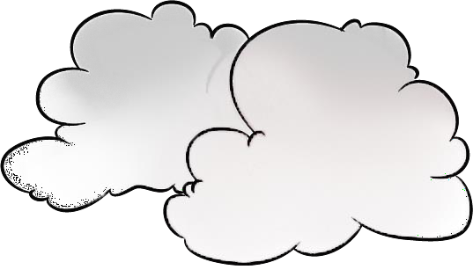

“Clouds come floating into my life, no longer to carry rain or usher storm, but to add color to my sunset sky.” – *Rabindranath Tagore*

Understanding your limitations inside and outside the school is just as important as looking into other aspects, like life experiences, social economic status, lifestyle, values, and beliefs. All of these can influence your achievement of life goals. These life goals are great motivational factors for you to keep going and be inspired in being the best, especially when unexpected life setbacks happen, such as the current Covid- 19 pandemic.

Indeed, continuing to focus on your studies is one of the best foundations that you can build. Specifically, consider the advantages and disadvantages of using effective study habits as your guide to develop routines—things that you can do on a regular basis which can help you achieve academic success. As a learner, you constantly face several things that demand your time for school or family. But knowing your priorities or what is important in life will guide you to do what is best.

In this module, you can learn how to be a strong-minded individual who knows how to manage activities and time well and who can share effective study habits which will be helpful to lifelong learning.

# Artboard 14@5xLet’s Try This

### Suggested Time Allotment: 5 Minutes

**How Do I Study?**

1. Identify the possible challenges of a learner in each picture.
2. Write your answers on a clean piece of paper to be followed by your answers to the processing questions.

1. 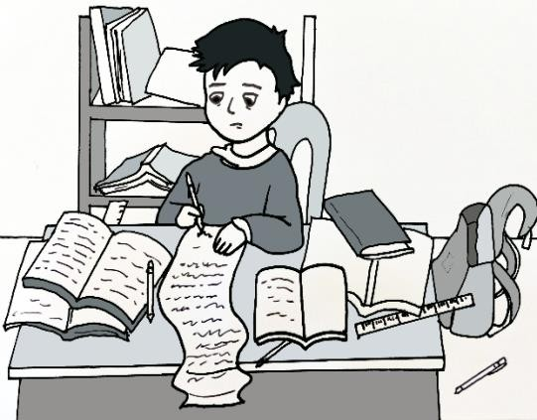 2. 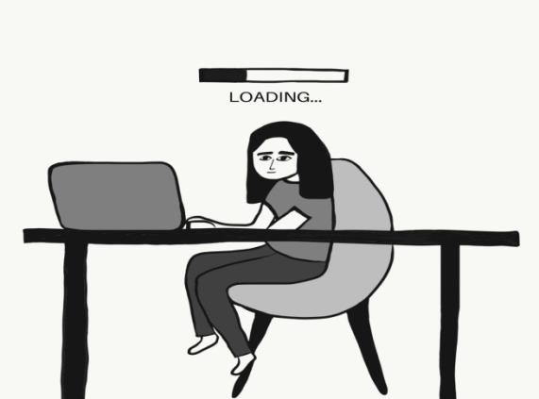

Typing what he learned but can’t remember lessons.

Writes what he learned.

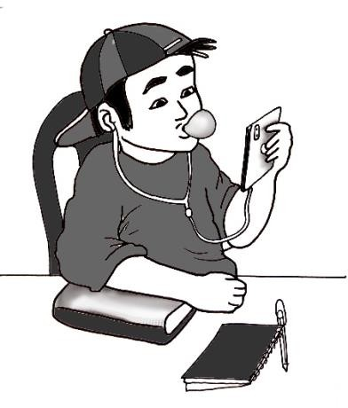3. ***4***

Reading without comprehension.

Procrastinating before studying

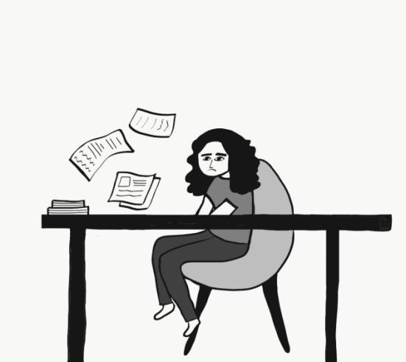

**Processing Questions:**

1. What is the most challenging situation for you in the pictures? Number One, because he puts more effort to review and study the lesson however he will retain more knowledge than any other situations.
2. Among the challenges presented, where can you relate the most? Why? Typing what you’ve learned, because even though we put less effort in it, we usually don’t retain information better.

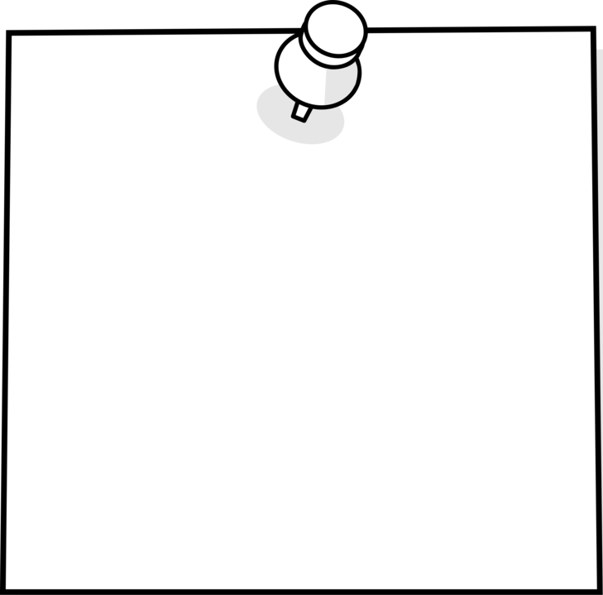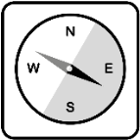

1. How do you overcome and deal with it positively? By altering those two methods, such as taking notes using physical pens and notebooks but studying them by gamifying those lessons using tools and websites.

# Let’s Explore This

### Suggested Time Allotment: 15 Minutes

**The Clouds of One’s Life**

Pick the different challenges written in the clouds that you have encountered or are facing right now. Then, copy the table below on a sheet of paper/bond paper and write your answers including your answers to the processing questions.

Difficulty in understanding a subject

Not enough food for family everyday

Need to take care of younger siblings while studying

Struggling to adjust in distance-learning

Lack of conducive space for learning

Procrastination or lack of motivation to study

Distracted by a lot of things at home (TV,

house chores, social media, online games, etc.)

### The Cloud of One’s Life Worksheet

**Name: Paul Gerald D. Pare Date: 11-04-20 Grade & Section: 9 - Adenine**

|  |  |  |
| --- | --- | --- |
| **Challenges met in school** | **Factors or reasons in experiencing challenges** | **What are the actions to do**  **to still have a good study habit?** |
| **Example:** Not enough food for family everyday | My parents are jobless | Look for opportunities to earn while considering my safety, and allot time to focus on my  schoolwork. |
| 1. Difficulty in understanding a subject | Not enough time to teach us. | Self – study by learning in reading books and articles, or lessons in platforms like YouTube. |
| 1. Distracted by a lot of things at home (TV,   house chores, social media, online games, etc.) | High Dopamine activities that keeps us addicted and entertained. It doesn’t benefits us and make us unproductive. | Put more effort before I could access those activities or material. An example of it is removing the battery of remote and put it in drawer, and putting a book on the couch ready to read. |
| 1. Need to take care of younger siblings while studying | Parent or guardian is outside and left my sibling. | Managing time better to provide time for my sibling and giving her care and support from me. |
| 1. Procrastination or lack of motivation to study | Attracted by someone in our family to do that thing or inviting me to play with them. | Do less important tasks that doesn’t have a deadline or long deadline. |
| 1. Struggling to adjust in distance-learning | Technical Difficulties and other problems. | Cooperate with teachers and help them if they have technical difficulties. |
|  |  |  |
| **7.** |  |  |

***Processing Questions:***

1. What do you feel when you recall those challenges? I feel very hard to accomplish and complete studying when there are other challenges in my way.
2. How different or similar are the study habits in various challenges? They are pretty similar in causes of those, because the reason why I experience it is just simply not managing my time properly and unproductiveness.
3. How do you look at these challenges in relation to your academic success? These challenges seems pretty difficult to deal with but if actions are done immediately then the challenges aren’t that big of a deal.

# Artboard 15@5xKeep in Mind

*Suggested Time Allotment: 10 Minutes*

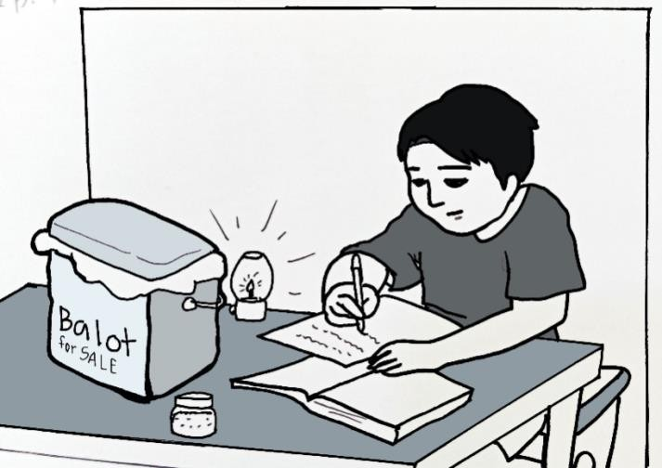

Challenges are normal occurrences in life. No single person can say that he or she has never encountered a challenge. From the time you were born as a baby, you struggled to crawl, to walk and to talk. As a toddler, you struggled to contain your

tantrums when you did not get what you wanted. As you added years in your life, you began to notice that the challenges you experienced became more varied, complex and difficult than before.

This health crisis situation that we are experiencing is a challenge in itself. We sometimes struggle to remember and apply all the necessary health and safety protocols from authorities. We struggle to avoid going to places if it is not necessary. We struggle to find safe ways to keep in touch with family, friends and loved ones while observing physical distancing. Even the learning setup is a challenge not only for you but for your classmates, parents, family members, teachers, and friends, as well.

Thus, everyone experiences challenges even before COVID-19. Could you imagine a life without challenges? A life where you don’t have to overcome any challenge at all? Regardless of its kind, we must constantly equip ourselves with ways on how we can rise above these challenges and deal with it positively. We have to develop effective study habits for the attainment of exemplary performance not only in school but in life later on.

## Below are the suggested strategies or ways to help you achieve academic success:

S - Set your academic goal for this school year.



T - Track your development through daily and weekly study plan.

R - Recognize the need for help or assistance from your parents, teachers and other adults in relation to your academic needs.

A - Accomplish your learning tasks ahead of time.



T - Thoroughly check the quality, quantity and presentation of your outputs before submission.

E - Exercise efficiency in the use of time, materials and efforts in achieving academic goal.

G - Gather all possible resources from books and other resources in order to have better understanding of the topic in your classes.

Y - Yearn to perform better and remember your motivation, study skills and study habits.

## Likewise, as much as possible learn to avoid the following:

W - Wasting time or doing irrelevant activities while having classes like playing online games, chatting, watching movies or TV series and daydreaming

A - Allowing peers to dictate your plans and actions



S – Stressing yourself to the point that you cannot function well

T – Thoughts that are negative like difficulty of the subject, chance of failure and inability to learn new lessons

E – Exhibiting unhealthy behavior (e.g. poor sleeping habits, excessive use of gadgets, not taking time to relax)

Keep in mind that the strategies discussed above cannot be mastered overnight. All study habits which are proven effective and efficient take time, hard work and practice. Whenever you take it upon yourself to apply the strategies seriously, you will begin to see that the challenges you encounter within and outside the school setting are not as overwhelming or discouraging as before. Navigating life, with or without the presence of a crisis situation such as the Covid-19, becomes more manageable if you are familiar with the strategies or ways that will lead you towards academic success.

For adolescent learners like you, some of the most needed study habits in your age group are time management, note-taking, managing distractions, doing advance readings and of course listening attentively, even if face-to-face classes for now are temporarily not being conducted. While it is ideal to practice every single effective study habit, all learners have preferential study habits depending on their learning styles and personal circumstances.

Similarly, avoiding unhelpful routines that hinder a learner from academic success also takes practice. It takes a lot of determination, focus and self-control to nurture your ability to say “no” to distractions and unnecessary activities, especially now that you do a lot of studying by yourself because of the pandemic.

**You Can Do It!**

*Suggested Time Allotment: 10 Minutes*

1. Copy the illustration of a pie below on a clean sheet of paper/bond paper.
2. List down your expectations before the start of School Year 2020-2021 as well as the things that happened during the first month of classes.

More modules and many time to accomplish them

Less modules and less time to accomplish them.

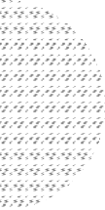

Things that Happened During the First Month of Classes

My Expectations Before the Start of School Year 2020-2021

**My Story Pie**

# C:\Users\chea18\Documents\modules\icons\Artboard 3@5x.pngWhat I Have Learned

Suggested Time Allotment: 9 Minutes

### Sentence Completion

On a clean sheet of paper/bond paper, complete each sentence below by writing the best phrase that applies. Select your answers from the boxes.

|  |  |  |  |
| --- | --- | --- | --- |
| **good study habits** | **self-esteem** | **take a deep breath** | **activities** |
| **cramming** | **goals** | **focus** | **group study** |

* 1. Take a deep breath, relax and do not put extreme, unnecessary pressure on yourself during your lessons.
  2. One way of having good study habits is to avoid cramming. It is better to review your notes ahead of time and study slowly but surely in a span of days than study everything in one go.
  3. Set specific goals that you can integrate in your routine. Consistency is one way of having good study habits.
  4. Having good study habits can be of immense help to students in acquiring knowledge and skills.
  5. Good study habits also boost self-esteem especially during exams and tests.
  6. Some people learn better when they join a group study.
  7. Each study session has its own activities. These may come in many forms such as memorizing vocabulary, solving problems or reading a whole chapter.
  8. When you are surrounded with distractions such as noise and social media, you tend to lose focus which can interfere in your study time.

# C:\Users\chea18\Documents\modules\icons\Artboard 5@5x.pngShare Your Thoughts and Feelings

*Suggested Time Allotment: 10 Minutes*

### Study Habits: Pros (+) and Cons (-)

* + 1. Copy the following table on a clean sheet of paper/bond paper.
    2. Write the pros (advantage) and cons (disadvantage) and your insight/s for each listed study habit.

|  |  |  |  |
| --- | --- | --- | --- |
| **Study Habit** | **Pros** | **Cons** | **Insight** |
| 1. Time  management | Have time with other tasks or in bonding with family | If too much of procrastinating, then it might cause to delay in important tasks | Watching with my family during night time because of time managing. |
| 2. Note-taking | Physically taking notes is better because you retain more information | Physically taking notes needs more effort than typing but typing notes will result to not remembering terms that are important. | Taking notes while in classes before the pandemic requires fast writing skills and only write the important terms. |
| 3. Managing  distractions | Gain more focus to finish tasks activities. | If important messages or emails have been announced then you might miss it out. | To access that material or activity that distracts you, you need more force/effort to achieve it. And make the habit or tasks that you want to accomplish easier to access. |
| 4. Doing  advance readings | Will know better and recite more while classes. | Less time for various procrastinating activities and bonding. | I did advance reading in a particular subject which is biotech physically written to remember it without notes. |
| 5. Listening  attentively | Gain more information and will know what topic are you in. | Less opportunity to finish tasks or homeworks. | When I already did advance reading I don’t listen that attentively because I already knew topics and terms. |

**====================**

**ANSWERS to What I Have Learned:**

**(1)** Take a deep breath, **(2)** Cramming, **(3)** Goals, **(4)** Good study habits,

**(5)** Self-esteem, **(6)** Group study, **(7)** Activities**, (8)**, Focus

## ====================

**References**

*Hussain, A. (2006). Effect of Guidance Services on Study Attitudes, Study Habits and Academic Achievement of Secondary School Students, Bulletin of Education and Research Vol. 28, No.1 pp. 35-45*

*Acido, M., (2010). High School Students’ Reasoning Skills and Their Study Habits and Attitude Towards Learning, Alipato: A Journal of Basic Education, Vol. 4 Available at* [*http://journals.upd.edu.ph/index.php/ali/article/viewFile/1769/1685*](http://journals.upd.edu.ph/index.php/ali/article/viewFile/1769/1685)

## ====================

**For inquiries or feedback, please write or call:**

Department of Education - Bureau of Learning Resources (DepEd-BLR) Ground Floor, Bonifacio Bldg., DepEd Complex

Meralco Avenue, Pasig City, Philippines 1600 Telefax: (632) 8634-1072; 8634-1054; 8631-4985

Email Address: [blr.lrqad@deped.gov.ph](mailto:blr.lrqad@deped.gov.ph) * [blr.lrpd@deped.gov.ph](mailto:blr.lrpd@deped.gov.ph)